Model Aeronautics
Association of Canada
Unit 9, 5100 South Service Road
Burlington, ON L7L 5H4
Attn: Linda Patrick cc Chris Brownhill - FAI Committee Chairman
cc Roly Worsfold - Chair of Chairs
Hi Linda,
The 2017 F2B Team Trials were held on Sunday August 13th at the Beanfield in Dresden Ontario. The Team Trials were conducted in conjunction with the Southern Ontario Control Line Championships. The 2018 F2B World Championships are scheduled for July 14-20 2018 in Landres France.
The Team Trials were organized by CD John McFayden 14681L and judging was handled by two experienced F2B competitors namely Chris Brownhill 3797L and Len Bourel 14801. Tabulator was Naomi Macklem 82384.
There were 5 entrants in the Team Trials, Konstantin Bajaikine 61045, Peter Hanson 65002, Kim Doherty 32008, Pat Mackenzie 8177L and John McFayden 14681L.
The results were as follows:
Pilot | Score
Peter Hanson | 590 | 1 st
Konstantin Bajaikine | 587 | 2 nd
Pat Mackenzie | 562 | 3 rd
John McFayden | 531.5 | Alternate
Kim Doherty | 528.5

Enclosed is a cheque for $125 for the FAI Travel Fund collected at this event.
Respectfully submitted,

John McFayden 14681L
Committee Chair, Control Line Precision Aerobatics
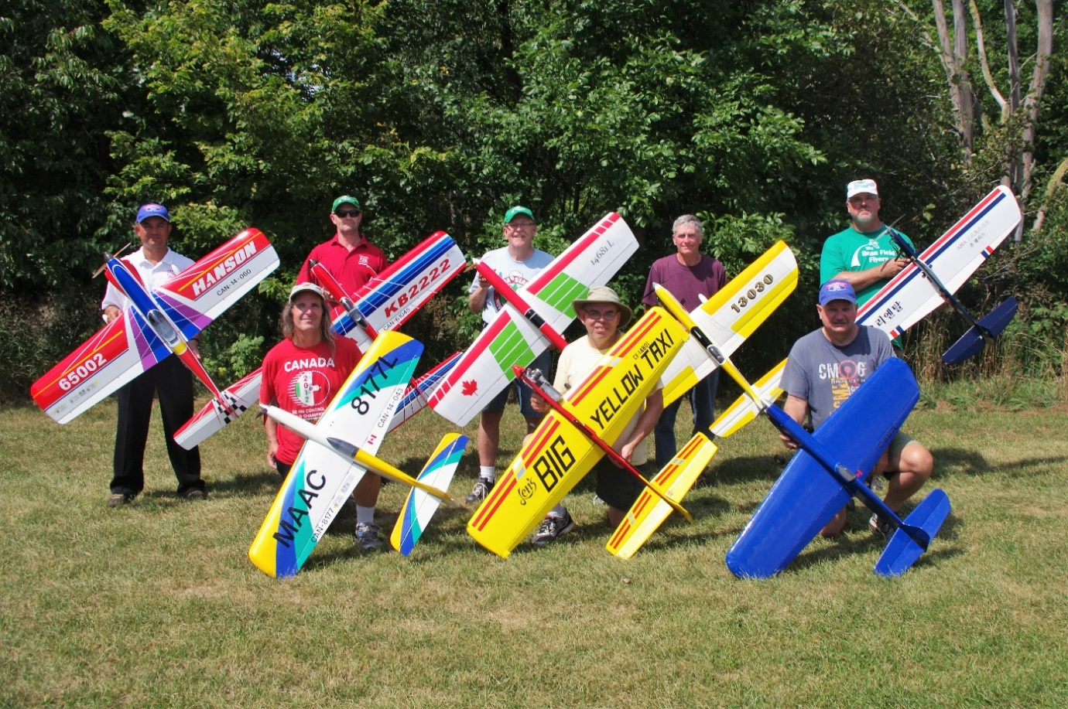

Back Row L to R : Peter Hanson, Konstantin Bajaikine, John McFayden, Bill Trumble, John Paris.
Front Row L to R : Pat Mackenzie, Len Bourel, Kim Doherty
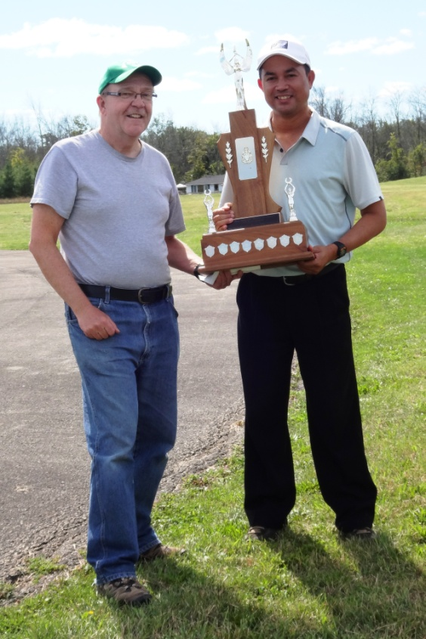

John McFayden presenting Peter Hanson the Rob Kolarik Trophy as the 2017 F2B Team Trials Champion.

